Visit
The Loyalist Exhibits Online
Who Were The Loyalists? Where Did The Loyalists Come from?
Where Did They Settle? Who & What Did They Bring With Them?
What Did They Do? How Are You Related To Them?
Research and Study your Loyalist Genealogical connection
See our special compilation and presentation
of the most Important Historic Sites in the Bahamas & Caribbean
View Bahamian Cultural Exhibits including our special collection of Historic Junkanoo Performances
The Loyalist Exhibits Package
Includes the following items
FotoBanker Membership Voucher
Flash Drive/DVD of Historic Places in the Bahamas & Documentary Film
Book on History and Places of the Bahamas
'What to See in The Bahamas' Tour Voucher
Membership in our Online Genealogy Network
A Special Collection of the Music of The Bahamas
Conch Shell/Conch Shell Product
Purchase this important souvenir package for only $20
www.junkanooart.com
******
-Get a Free Integrated Marketing Automation Publishing (IMAP) Website- Upload, Store & Bank Photos & Videos from your Trips & Events
The Free fully functional Website can be used for any legal purpose and is automatically established upon Free Registration on the NMEX Platform.
******
Submit Your Photos & Videos for use in the
"The Loyalist Adventures" Documentary Film Project
www.LoyalCarib.com
Bank Your Fotos & Win Money and Prizes with FotoBanking at www.FotoBanker.com
Upload your Photos and FotoVote on our Various FotoContests at
www.FotoVoter.Com
You must be registered and logged in to upload photos, and to view most photos.
Registration is Free, & automatically gives you a full function, Integrated Marketing Automation & Publishing (IMAP) Website
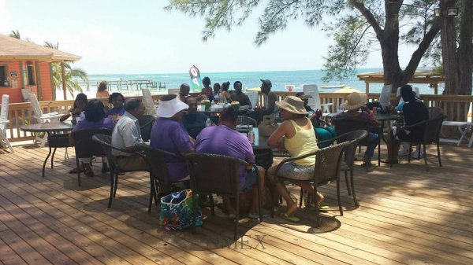
Bank Your Fotos & Win with FotoBanker.com, FotoOpps.com, FotoMatcher & FotoVoter.com 